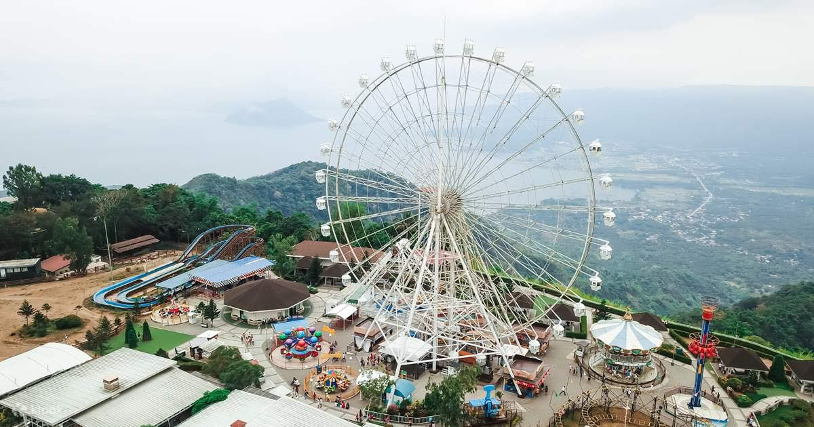Tagaytay is known for being one of the most frequented places in the south because of its outstanding scenery and abundant activities. It overlooks Taal Lake and Taal Volcano and has a cold climate, given its high altitude. This makes both the volcano and lake viewable from several vantage points. This also explains where it gets its moniker and why tourism is one of its major industries. Part of what makes it special is not what’s within its territory but what one can admire from there, the one that I love the most there is the places called sky ranch because you not only enjoy the stunning view of Taal Volcano and Taal Lake but you can also enjoy the rides there like Zipline, Super Viking, Sky Cruiser, Nessi Coaster as well the giant and tallest Ferris wheel “which they called the Sky Eye”, that give you a great views of the Taal volcano and Taal Lake. To start, in are second tourist spots I like you to know this place is also one of the most popular tourist attractions in Tagaytay and one of the most familiar memories that people have when they think of Tagaytay. This place is called Picnic Grove, What I love about this place is that it has a lot of greenery all around and it has outstanding views and ambiance. I kind of disappointed that the area for horses Riding is very little but There are also some rides are nice like Zipline and Ferris Wheel that also give you a great view of the Taal volcano and Taal Lake. Please note I will not recommend going here if your family has a tight budget because everything here is expensive but overall, it was a nice place to wander around and it’s good for small walks. Nice for family picnic because have a good view of Taal volcano and Taal Lake.